**LABORATORY PROGRAM – 9**

Write a program that creates a user interface to perform integer divisions. The user enters two numbers in the text fields, Num1 and Num2. The division of Num1 and Num2 is displayed in the Result field when the Divide button is clicked. If Num1 or Num2 were not an integer, the program would throw a NumberFormatException. If Num2 were Zero, the program would throw an Arithmetic Exception Display the exception in a message dialog box.

**OBSERVATION :**

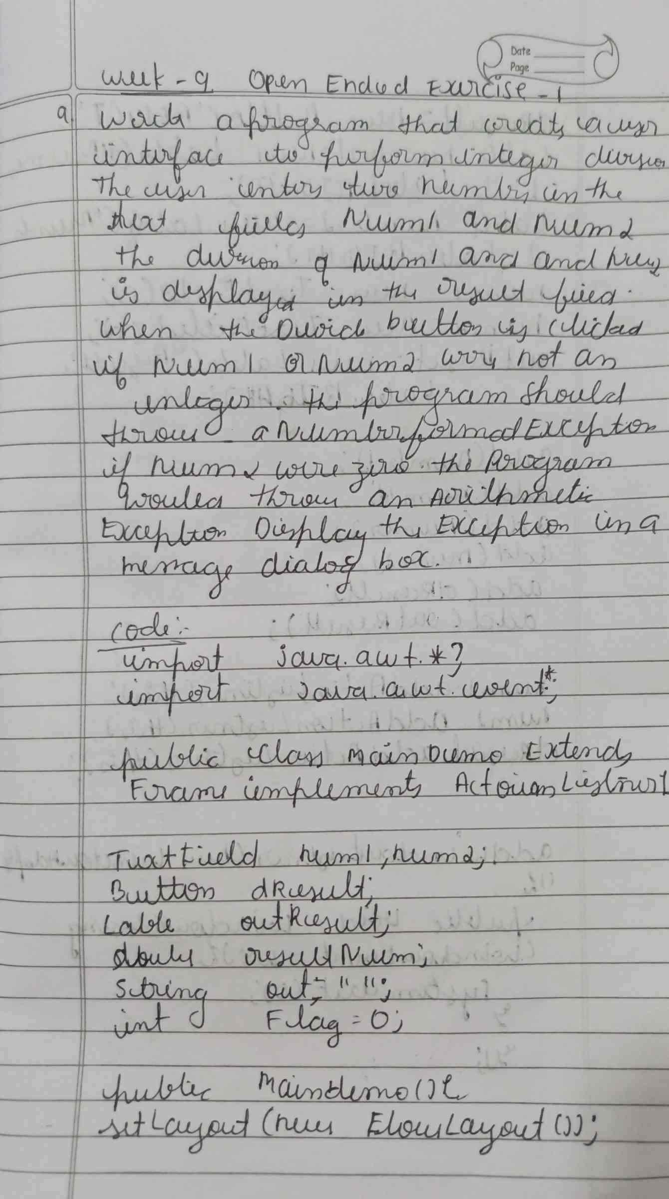

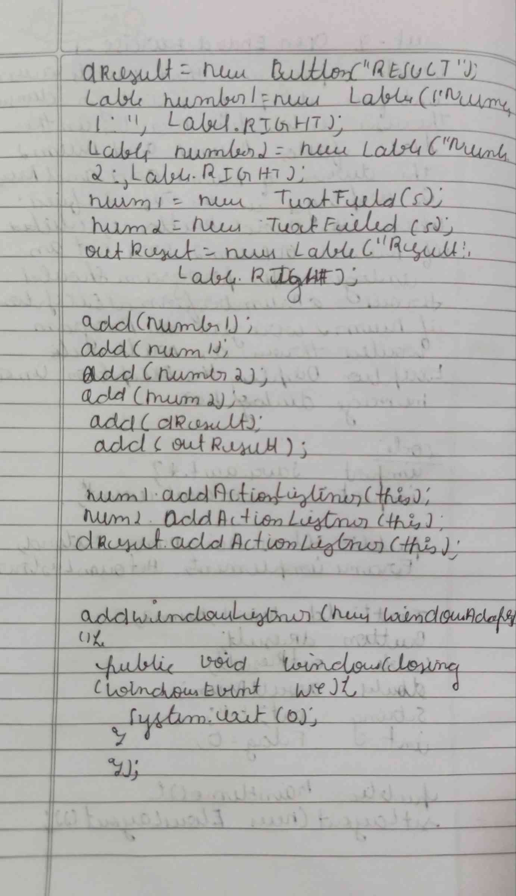

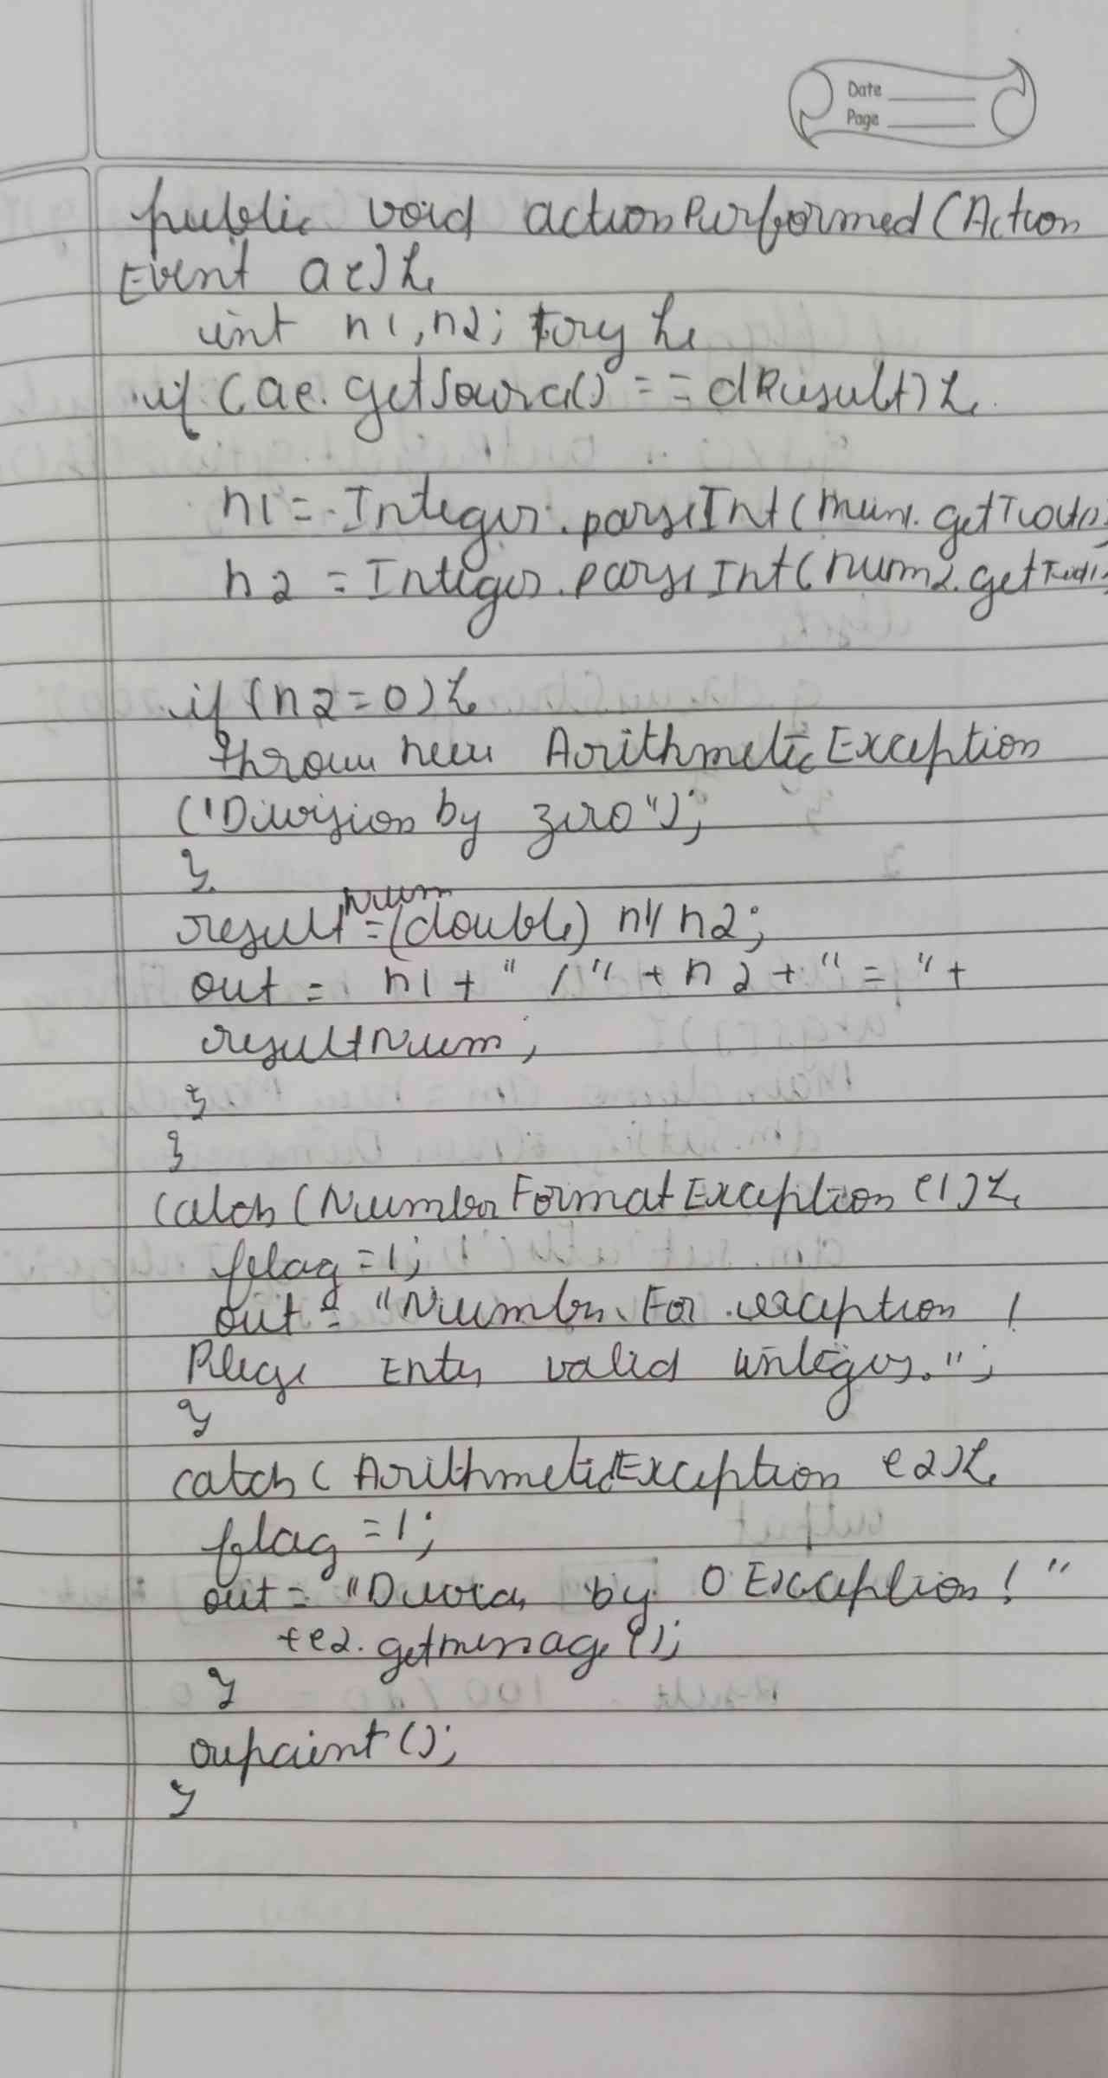

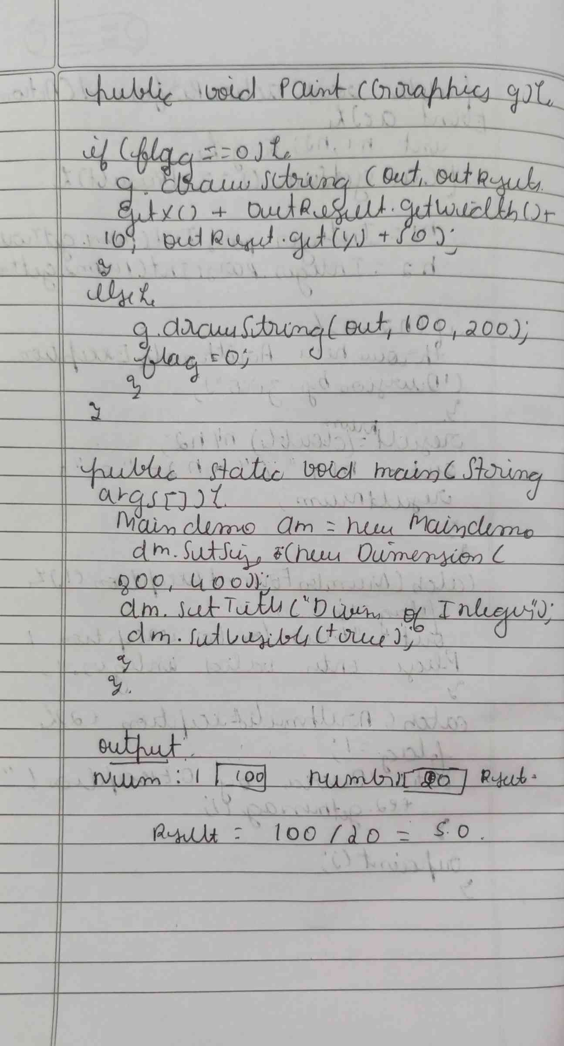

**CODE :**

**import java.awt.*;**

**import java.awt.event.*;**

**public class Maindemo extends Frame implements ActionListener {**

**TextField num1, num2;**

**Button dResult;**

**Label outResult;**

**String out = "";**

**double resultNum;**

**int flag = 0;**

**public Maindemo() {**

**setLayout(new FlowLayout());**

**dResult = new Button("RESULT");**

**Label number1 = new Label("Number 1:", Label.RIGHT);**

**Label number2 = new Label("Number 2:", Label.RIGHT);**

**num1 = new TextField(5);**

**num2 = new TextField(5);**

**outResult = new Label("Result:", Label.RIGHT);**

**add(number1);**

**add(num1);**

**add(number2);**

**add(num2);**

**add(dResult);**

**add(outResult);**

**num1.addActionListener(this);**

**num2.addActionListener(this);**

**dResult.addActionListener(this);**

**addWindowListener(new WindowAdapter() {**

**public void windowClosing(WindowEvent we) {**

**System.exit(0);**

**} });**

**}**

**public void actionPerformed(ActionEvent ae) {**

**int n1, n2;**

**try {**

**if (ae.getSource() == dResult) {**

**n1 = Integer.parseInt(num1.getText());**

**n2 = Integer.parseInt(num2.getText());**

**if (n2 == 0) {**

**throw new ArithmeticException("Division by zero"):}**

**resultNum = (double) n1 / n2;**

**out = n1 + " / " + n2 + " = " + resultNum;**

**}**

**} catch (NumberFormatException e1) {**

**flag = 1;**

**out = "Number Format Exception! Please enter valid integers.";**

**} catch (ArithmeticException e2) {**

**flag = 1;**

**out = "Divide by 0 Exception! " + e2.getMessage();}**

**repaint();}**

**public void paint(Graphics g) {**

**Font customFont = new Font("Serif", Font.BOLD, 20);**

**g.setFont(customFont);**

**if (flag == 0) {**

**g.drawString(out, outResult.getX() + outResult.getWidth() + 10, outResult.getY() +20);**

**} else {**

**g.drawString(out, 100, 200);**

**flag = 0;**

**} }**

**public static void main(String[] args) {**

**Maindemo dm = new Maindemo();**

**dm.setSize(new Dimension(800, 400));**

**dm.setTitle("Division Of Integers");**

**dm.setVisible(true);**

**}**

**}**

**OUTPUT :**

